Ideation Phase
Empathize & Discover

Date | 3 October 2026
Team ID
Project Name | PocketSmart AI: Your Smart Budget & Recommendation Assistant
Maximum Marks | 4 Marks

Empathy Map Canvas:
An empathy map is a simple, easy-to-digest visual that captures knowledge about a user’s behaviours and attitudes.

It is a useful tool to helps teams better understand their users.
Creating an effective solution requires understanding the true problem and the person who is experiencing it. The exercise of creating the map helps participants consider things from the user’s perspective along with his or her goals and challenges.
Example:
1. SAYS | 2. THINKS
• "I need to set up my room decor under ₹15,000 without overspending."  • "Checking prices across multiple tabs takes too much time."  • "Is there an easy tool to track my income and expenses in one dashboard?" | • "Am I spending too much on individual decor items?"  • "How can I get the best value across Amazon and IKEA simultaneously?"  • "I hope I don't run out of budget before finishing my party planning."

3. DOES | 4. FEELS
• Opens multiple tabs for e-commerce platforms (Amazon, IKEA, Swiggy, Zomato, OYO) manually.  • Calculates total costs line-by-line using standard calculators or spreadsheets.  • Uses PocketSmart AI to generate instant, AI-tailored packages within strict limits. | • Stressed / Overwhelmed by scattered pricing and potential overspending.  • Relieved & Confident when seeing real-time expense calculations and AI package recommendations.

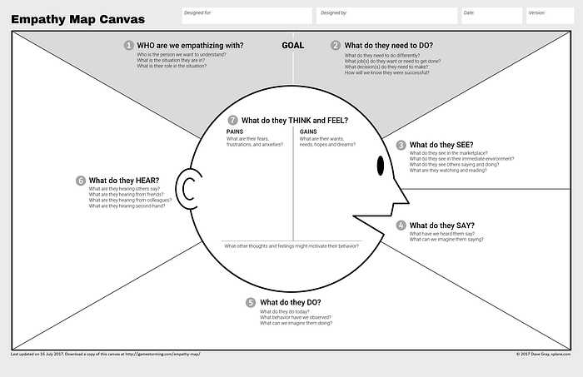
Here is the official reference link for that specific 7-part Empathy Map Canvas (designed by Dave Gray / XPLANE):

- Official Gamestorming Empathy Map Canvas Template:
- https://gamestorming.com/empathy-map/

